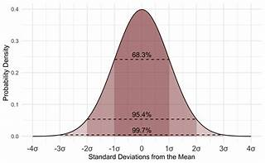

Explore

**Statistical analysis** involves collecting and analyzing data to discern patterns, relationships, and insights. It helps us make informed decisions based on data-driven evidence.

Here are **five free reference links** where you can learn more about statistical analysis:

1. [**Coursera**: Explore their article on **“What Is Statistical Analysis? Definition, Types, and Jobs”** to understand the fundamentals and career opportunities in this field1](https://www.coursera.org/articles/statistical-analytics).
2. [**Built In**: Read their concise explanation of statistical analysis and its importance in research and data interpretation](https://www.coursera.org/articles/statistical-analytics)[2](https://builtin.com/data-science/statistical-analysis).
3. [**Simplilearn**: Dive into their comprehensive guide on **“Types, Methods, and Examples of Statistical Analysis”** to learn about descriptive, inferential, predictive, and other types of statistical analysis](https://www.coursera.org/articles/statistical-analytics)[3](https://www.simplilearn.com/what-is-statistical-analysis-article).
4. [**Business News Daily**: Discover how statistical analysis is used to identify trends, remove bias, and inform decision-making in business intelligence](https://www.coursera.org/articles/statistical-analytics)[4](https://www.businessnewsdaily.com/6000-statistical-analysis.html).
5. [**DataCamp**: Explore their tutorial on **“Unveiling the Magic of Statistical Machine Learning”**, which delves into the fusion of statistics and machine learning](https://www.coursera.org/articles/statistical-analytics)[5](https://www.datacamp.com/tutorial/unveiling-the-magic-of-statistical-machine-learning).

Remember, statistical analysis is a powerful tool that empowers us to extract meaningful insights from data, whether it’s for scientific research, business decisions, or personal understanding. Happy learning! 📊📈